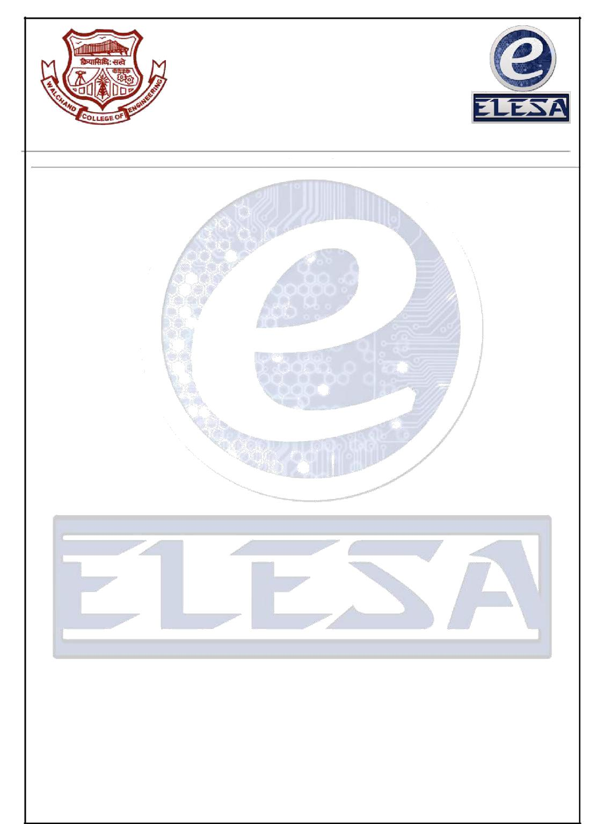
Walchand College of Engineering, Sangli.

(An autonomous institute)
&
Electronics Engineering Students’ Association
(ELESA)

Presents
ELECTROVERT 2k18

Email: www.elesa.in Website:

ELECTROVERT 2k18

EVENT STRUCTURE
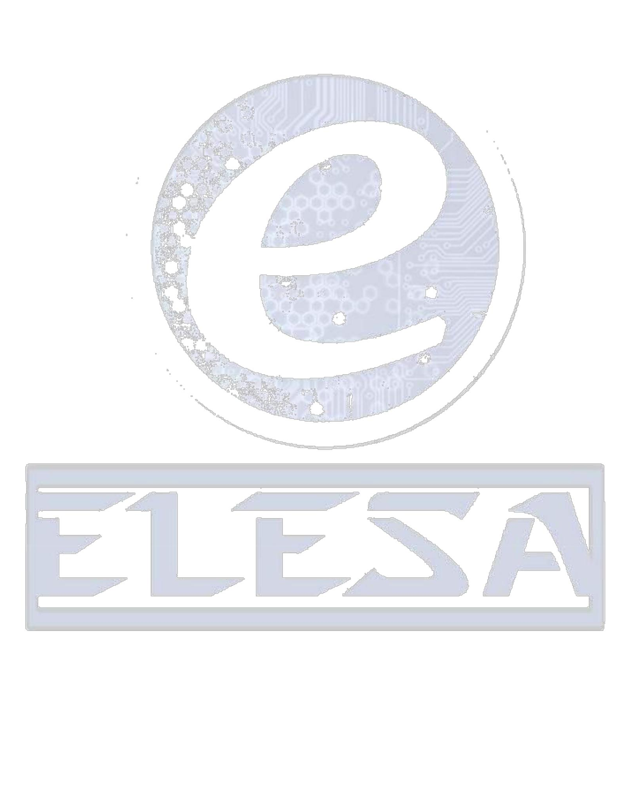
EXORDIUM

EXORDIUM :
New beginning. As the name suggests ,this event is organized exclusively for First Year Engineering Students. The prime purpose behind organizing this event is to provide first year students with a platform where they can show and affirm their knowledge, command over language and versatility.

- Each team will be consisting of maximum 2 members.

- Expected count of entries for the event is about 150.

- Entry fee will be Rs.80+80. (+80Rs. is for 2nd round shortlisted teams/participants)

- Event will be conducted in 3 rounds.

Event Structure:

    - Round 1-MCQ: (10:30 am to 12:00 pm)

The first round will consist of MCQ.It includes topics like aptitude,GK ,verbal skills, logical reasoning, puzzles etc .

    - Round 2-Presentation (1:30pm to 3:00pm)

The second round each team will be provided with a topic. They have to make interaction about that topic and come up with a solution along with the presentation.

    - Round 3-Surprise : (3:30pm to 5:00pm)

The third round will be totally a surprise round wherein management skills of the participants will be tested.

